Making a shadow

Matilda is thinking about how a shadow is made.
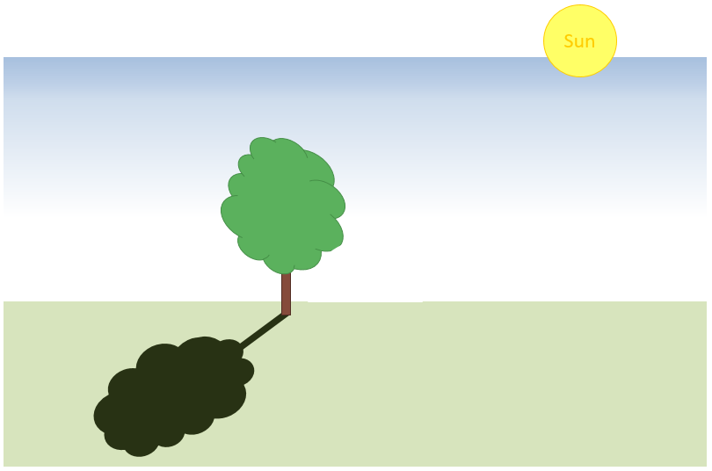

Which is the best description of how the shadow is made?
Put a tick (✓) in the box next to the best answer.
A | The light can’t pass through the tree so the grass is not lit up.
B | The light sets off from the sun but can’t cross the tree so it’s black.
C | The tree stops the sun from shining any further, so the tree makes the shade.
D | The Sun shines on the tree, and the shadow is a reflection of the tree.

Physics > Big idea PSL: Sound, light and waves > Topic PSL1: Sound and light > Key concept PSL1.2: Characteristics of light
Diagnostic question
Making a shadow

Overview
Learning focus: | Light travels in straight lines at very high speeds.
Observable learning outcome: | Explain how shadows are formed.
Question type: | Simple multiple choice
Key words: | Light, travel, straight-line

What does the research say?
To explain how a shadow forms needs an understanding of how light travels in straight lines from a source. Younger students commonly have alternative explanations or misunderstandings that are challenged by the scientific explanation for shadows. This question can help identify persisting misunderstandings.
Most 10 and 11 year olds think that light is found only in bright areas and not in the space between, for example, a source of light and the patch of light it makes (Guesne, 1985; Allen, 2014). This may be because when students think of light, they do not necessarily think of it as travelling. They may instead think of rays as like ‘wires of light’ or roads going from A to B (Driver et al., 1994).
In a study of 456 15-year-olds, Ramadas and Driver (1989) found that many students thought light rays were not like ordinary light, but described them variously as long, thin or flashing. These ideas are not helped by the fact that students cannot see the path light takes in normal circumstances.
Guesne (1985) found many students aged 10-11 viewed shadows as a reproduction of an object’s shape. Young children confuse ‘shadow’ and ‘reflection’ and may draw faces on a shadow. Some may think a shadow is part of an object which is made visible by light. By age 14 Guesne found the majority of students recognised light as an entity and could use this notion to explain shadows in bright light. She also found that many did not think shadows formed when the light was less than bright.
Ways to use this question
Students should complete the question individually. This could be a pencil and paper exercise, or you could use an electronic ‘voting system’ or mini white boards and the PowerPoint presentation.
The answers to the question will show you whether students understood the concept sufficiently well to apply it correctly.
If there is a range of answers, you may choose to respond through structured class discussion. Ask one student to explain why they gave the answer they did; ask another student to explain why they agree with them; ask another to explain why they disagree, and so on. This sort of discussion gives students the opportunity to explore their thinking and for you to really understand their learning needs.
Differentiation
You may choose to read the questions to the class, so that everyone can focus on the science. In some situations it may be more appropriate for a teaching assistant to read for one or two students.
Expected answer
Answer A is correct
How to respond - what next?
Answer A describes how light from the Sun travels and is blocked by the tree, so there is an absence of direct light behind the tree.
Answer B is a partial answer, with no explanation for why there is less light. Students giving this answer may perhaps be imaging the shadow as a kind of reflection or as a part of the tree revealed by the sunlight. They may have the scientific understanding of how the shadow is formed.
Answer C reveals a stronger possibility of the misunderstandings that may be present from answer B, and answer D is clearly an alternative explanation.
If students have misunderstandings about the scientific explanation of how shadows form, it can help to explore the idea with a class discussion and then give the students an activity in which they can practise using the explanation to explain the formation of some other shadow. This can help consolidate their understanding and often works best when completed in pairs or small groups which encourage social construction of new ideas through dialogue.
The following BEST ‘response activity’ could be used in follow-up to this diagnostic question:
- Response activity: Extra light shadow
Acknowledgments
Developed by Peter Fairhurst (UYSEG), from York Science activity PLC1.2b by Mary Whitehouse (UYSEG).
Images: UYSEG
References
Allen, M. (2014). Misconceptions in Primary Science, Second edn Berkshire, UK: Open University Press.
Driver, R., et al. (1994). Making Sense of Secondary Science: Research into Children's Ideas, London, UK: Routledge.
Guesne, E. (1985). Light. In Driver, R., Guesne, E. & Tiberghien, A. (eds.) Children's Ideas in Science. Milton Keynes: Open University Press.
Ramadas, J. and Driver, R. (1989). Aspects of Secondary Students' Ideas About Light, Leeds: University of Leeds Centre for Studies in Science and Mathematics Education.

